- Message Format:
  - The SYSLOG message format on rfc5424:
Message Field | Message Format
SYSLOG-MSG | HEADER SP STRUCTURE-DATA [SP MSG]
  - The “SEL Event Records” table:
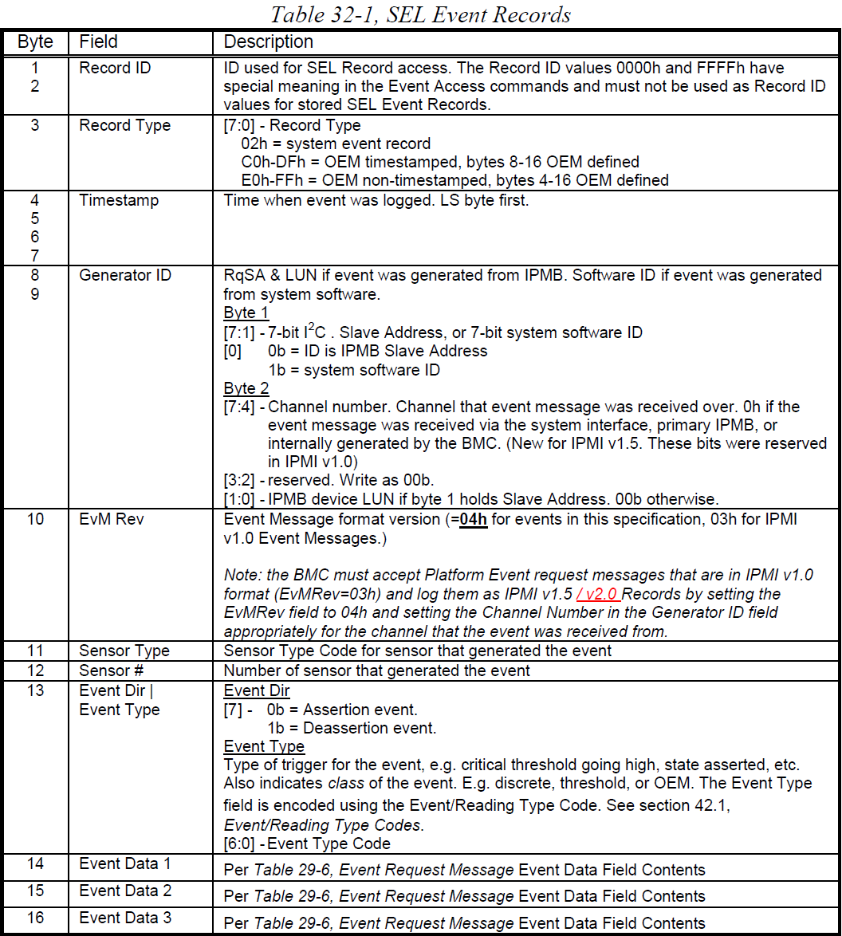

  - The SYSLOG mapping table with SEL fields:

- SYSLOG Fields:
  - PRIVAL:
The facility value is 1(user-level message).

The severity will depend on the event type.
If the event type is threshold, the non-recoverable is "Alert", the critical is "Critical" and the non-critical warning is "Warning".
The others are "Information".

  - VERSION:
1
  - HOSTNAME:
Fill the HOSTNAME on the BMC embedded OS.
  - APP-NAME:
Fill “BMC”.
  - PROCID:
Fill the BMC version number.
  - MSGID:
The “Record ID” of SEL with HEX format.
  - TIMESTAMP:
Convert from “Timestamp” of SEL with UTC format.
(g), STRUCTURED-DATA?

  - SD-ELEMENT:
NILVALUE
  - MSG:
Fill the RAW data for Record ID, Record Type, Timestamp, Generator ID, EvM Rev, Sensor Type, Sensor #, Event Type, Event Data 1, Event Data 2, Event Data 3 with Least Significant Byte first.
  - Structured Data IDs:
NILVALUE

- Example:
  - SEL for PSU present on WebGUI:
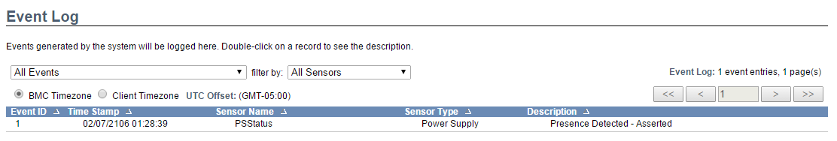
  - SEL for PSU present on HEX file:
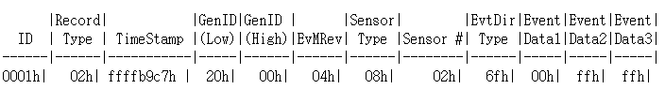
  - SEL for PSU present on SYSLOG:
<14>1 2106-02-07T01:28:39.0Z HOSTNAME BMC 1521A1X.XXX 0100 - 0x02 0xC7 0xB9 0xFF 0xFF 0x20 0x00 0x04 0x08 0x02 0x6F 0x00 0xFF 0xFF

